Internet Protocol Version 6(IPv6)

A Term Paper submitted for partial fulfillment of the course COMP 204

Department of Computer Science and Engineering

Kathmandu University

Submitted by:

Sanjog Sigdel

Computer Science

Roll: 57

Submitted to:

Course Instructor

Mr. Sushil Nepal

DoCSE,KU

2014

Sanjog Sigdel

sigdelsanjog@gmail.com

6/25/2014

# ABSTRACT

Electronic devices such as computers, laptops, smart phones, cars as well as many electronic appliances use unique address which is Internet Protocol Version 4.IPv4 can only assign IP to 4,294,967,296 devices which is near to an end. So due to the depletion of the pool of unallocated IPv4 address IPv6 is an alternate possibility. A study on Internet Protocol version 6, its origin, architecture, header format, advantages and comparison over IPv4 will be illustrated.

Table of Contents:

ABSTRACT 0

List of Figures: 3

INTRODUCTION 4

1.1 BACKGROUND 4

1.2 MOTIVATION FOR RESEARCH 4

2 LITERATURE REVIEW 5

3 METHODOLOGY 6

3.1 WEB SURFING 6

3.2 BOOKS 6

4 DISCUSSIONS 7

4.1 DEFINITION 7

4.2 IPv6 HEADER FORMAT 7

4.3 Comparison with IPv4 9

4.4 IPv6 READINESS 10

4.5 IPv6 ADOPTATION 11

6 CONCLUSIONS 13

BIBLIOGRAPHY 14

# List of Figures:

*Fig 1: Decomposition of the IPv6 address representation into binary form*

*Fig 2: IPv6 Header Format*

*Fig 3: IPv4 address allocation*

*Fig 4: Ipv4 and IPv6 address allocation*

*Fig 5: IPv6 adoptation study on Google’s official website.*

*Fig 6: Worldwide adoptation of IPv6*

# INTRODUCTION

## 1.1 BACKGROUND

**IP address** or Internet Protocol address is a numerical label assigned to each device (e.g.,computer,printer,scanner)participating in a computer network that uses **Internet Protocol** for communication.[[1]](http://tools.ietf.org/html/rfc760) A name indicates what we seek while an address indicates where it is, a route indicates how to get there.IP addresses are binary numbers, but they are usually stored in text files and displayed in human-readable notations,**192.168.1.1**(for IPv4), and **2001:db8:0:1234:0:567:8:1** (for IPv6).

The designers of Internet Protocol defined IP address as a 32-bit number consisting of 4 octates and this system is known as **Internet Protocol Version 4 (IPv4)**.[[1]](http://tools.ietf.org/html/rfc760) This is the IP address we use today.

However due to enormous growth of the Internet users and the predicted depletion of available addresses a new version of IP (**IPv6**), using 128 bits for the address was developed in 1995 and was standardized as RFC 2460 in 1998[[2]](http://tools.ietf.org/html/rfc2460), which stands for Internet Protocol version 6.Development of IPv6 has been ongoing since mid 2000s.

## 

## 1.2 MOTIVATION FOR RESEARCH

In September 1981, RFC791 introduced the Internet Protocol v4 (IPv4)[[3]](http://tools.ietf.org/html/rfc791) and RFC793 introduced Transmission Control Protocol. In IPv4 an address consists of 32 bits which limits the address space to 232 which limits the address space to 4,294,967,296 unique addresses. Subnet of these have been distributed by Internet Assigned Numbers Authority(IANA)[[4]](http://tools.ietf.org/html/rfc791) and 16.8 million addresses is provided. *Therefore due to the depletion of the pool of unallocated IPv4 address IPv6 is an alternate possibility*because it can support approximately 3.4* 1038 addresses.

# 2 LITERATURE REVIEW

IPv6 is an internet layer protocol for packet-switched networking and provides end-to-end datagram.For a detail study of IPv6 I overviewed following reference materials:

**INTERNET PROTOCOL VERSION 6 (IPv6) SPECIFICATION, (December 1998)**[[5]](http://www.rfc-editor.org/search/standards.php): The official memo published by the Official Internet Protocol Standards provides a clear vision about the IPv6 Header formats,Extension Header order, Routing headers and many issues.

**SUSE LINUX- Administration Guide,Linux in the Network/ 14.2.IPv6-The Next Generation Internet(2012)** [[6]](http://www.novell.com/documentation/suse91/suselinux-adminguide/html/ch14s02.html): Chapter No.14 of the Administration Guide addresses the advantages of IPv6, IPv6 Address System and IPv6 structure.

**DATA COMMUNICATION AND NETWORKING, 5th Edition by Forouzan(2013):**This book mentions IPv6 addressing as the **“Next Generation IP”.** The main reason for adopting IPv6 rather than IPv4 is the address depletion of IPv4.

# 3 METHODOLOGY

Internet Protocol Version 6 is a standard protocol established by Official Internet Protocol Standards and it is responsible for the change and improvement in the protocol.Following methodologies were used to write this term paper:

## 3.1 WEB SURFING

**WIKIPADIA: IPv6**[[7]](http://en.wikipedia.org/wiki/IPv6): In an article titled IPv6 published in wikipedia detail information about Internet Protocol Version 6 is provided.It describes about the origin of IPv6, and purpose of its origin,It also compares with IPv4 and describes about the header formats.

**GOOGLE: IPv6 Statistics**[[8]](http://en.wikipedia.org/wiki/IPv6): In an article *“What if Internet ran out of room? In fact, it’s already happening”* published by google, google has mentioned the graph of IPv4 scarcity and IPv6 as alternative.

## 3.2 BOOKS

**DATA COMMUNICATION AND NETWORKING, 5th Edition by Forouzan(2013):** A detail description of IPv6 with its comparison with IPv4 as well as advantages, header formats and architecture of IPv6 is illustrated in this book.

# 4 DISCUSSIONS

## 4.1 DEFINITION

IPv6 is an Internet Protocol for packet switched internetworking and provides end-to-end datagram transmission across multiple IP networks.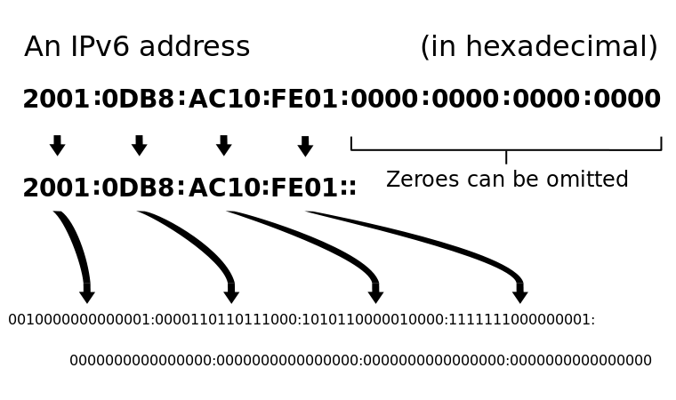

*Fig1: Decomposition of the IPv6 address representation into binary form*

## 4.2 IPv6 HEADER FORMAT[9]

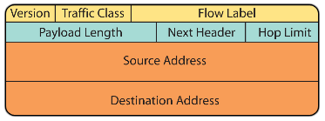

Fig 2: IPv6 Header Format

IPv6 contains the following fields:

**Source address**: It is of 128 bits and contains the IPv6 address of the originating node of the packet.

**Destination address:** It is of 128 bits and contains the IPv6 address of the recipient node of the packet.

**Version/IP version**: It is of 4 bits and contains the number 6.It indicates the version of the IPv6 protocol.

**Packet priority/Traffic class:** The 8-bit Priority field in the IPv6 header can assume different values to enable the source node to differentiate between the packets generated by it by associating different delivery priorities to them. This field is subsequently used by the originating node and routers to identify the data packets that belong to the same traffic class and distinguish between packets with different priorities.   
  
**Flow Label/QoS management:** The 20-bit flow label field in the IPv6 header can be used by source to label set of packets belonging to the same flow. A flow is identified by the combination of source address and of a non-zero flow.   
When routers receive the first packet of a new flow, they can process the information carried by the IPv6 header, Routing header, and Hop-by-Hop extension headers, and store the result (e.g. determining the retransmission of specific IPv6 data packets) in a cache memory and use the result to route all other packets belonging to the same flow (having the same source address and the same Flow Label), by using the data stored in the cache memory.   
  
**Payload length in bytes**: The 16-bit payload length field contains the length of the data field in octets/bits following the IPv6 packet header. The 16-bit Payload length field puts an upper limit on the maximum packet payload to 64 kilobytes. In case a higher packet payload is required, a Jumbo payload extension header is provided in the IPv6 protocol. A Jumbo payload (Jumbogram) is indicated by the value zero in the Payload Length field. Jumbograms are frequently used in supercomputer communication using the IPv6 protocol to transmit heavy data payload.   
  
**Next Header:** The 8-bit Next Header field identifies the type of header immediately following the IPv6 header and located at the beginning of the data field (payload) of the IPv6 packet. This field usually specifies the transport layer protocol used by a packet's payload. The two most common kinds of Next Headers are TCP (6) and UDP (17). The format adopted for this field is the one proposed for IPv4 by RFC 1700. In case of IPv6 protocol, the Next Header field is similar to the IPv4 Protocol field.   
  
**Time To Live (TTL)/Hop Limit (8 bits):**The 8-bit Hop Limit field is decremented by one, by each node (typically a router) that forwards a packet. If the Hop Limit field is decremented to zero, the packet is discarded. The main function of this field is to identify and to discard packets that are stuck in an indefinite loop due to any routing information errors. In case of IPv6 protocol, the fields for handling fragmentation do not form a part of the basic header. They are put into a separate extension header. Moreover, fragmentation is exclusively handled by the sending host. Routers are not employed in the Fragmentation process.

## 4.3 Comparison with IPv4

Because the headers of IPv4 packets and IPv6 packets are significantly different, two protocols are not interoperable. Following are the points for the comparison of IPv4 and IPv6 protocols.

**Larger Address Space:** The length of IPv4 is 32 bits while that of iIPv6 is 128 bits. So IPv6 can allocate 2128 or approximately 3.4*1038 address while IPv4 can allocate 232 addresses. Out of which only 14% of available addresses is utilized.

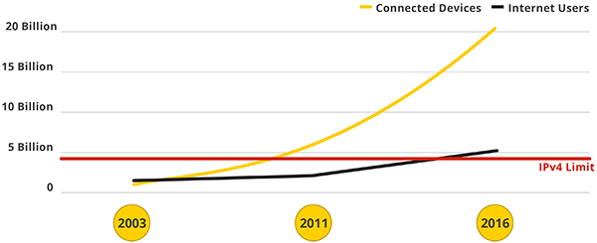

Fig 3: IPv4 addresses allocation[9]

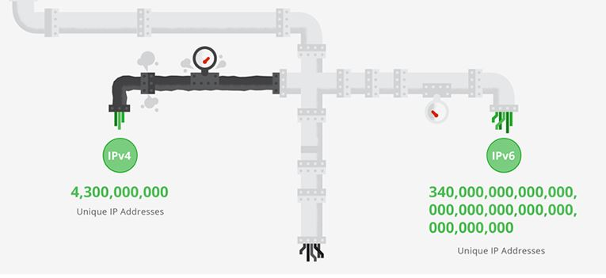

*Fig 4: Ipv4 and IPv6 space allocation[9]*

**Multicasting:** Multicasting the transmission of a packet to multiple destinations in a single send operation, is part of the base specification in IPv6.  In IPv4 this is an optional although commonly implemented feature. IPv6 multicast addressing shares common features and protocols with IPv4 multicast, but also provides changes and improvements by eliminating the need for certain protocols**.**IPv6 multicast address format providing a 32-bit block, the least significant bit of the address provides approximately 4.2 billion multicast group identifiers.

**Stateless address auto configuration (SLAAC):** IPv6 hosts can configure themselves automatically when connected to an IPv6 network using the [Neighbor Discovery Protocol](http://en.wikipedia.org/wiki/Neighbor_Discovery_Protocol) via [Internet Control Message Protocol version 6](http://en.wikipedia.org/wiki/Internet_Control_Message_Protocol_version_6)(ICMPv6) router discovery messages. When first connected to a network, a host sends a [link-local](http://en.wikipedia.org/wiki/Link-local_address) router solicitation multicast request for its configuration parameters; routers respond to such a request with a router advertisement packet that contains Internet Layer configuration parameters.

**Network-layer security**:[**Internet Protocol Security**](http://en.wikipedia.org/wiki/Internet_Protocol_Security)(IPsec) was originally developed for IPv6, but found widespread deployment first in IPv4, for which it was re-engineered. IPsec was a mandatory specification of the base IPv6 protocol suite, but has since been made optional.

**Mobility**: Unlike mobile IPv4, [mobile IPv6](http://en.wikipedia.org/wiki/Mobile_IPv6) avoids [triangular routing](http://en.wikipedia.org/wiki/Triangular_routing) and is therefore as efficient as native IPv6. IPv6 routers may also allow entire subnets to move to a new router connection point without renumbering.

IPv6 is comparatively the best alternative for the evolving problem of IP address scarcity. Also IPv6 is better in other features like Options extensibility, Jumbograms , privacy, addressing, tunneling and many other features.

## 4.4 IPv6 READINESS

Compatibility with IPv6 networking is mainly a software or firmware issue. However, much of the older hardware that could in principle be upgraded is likely to be replaced instead. The [American Registry for Internet Numbers](http://en.wikipedia.org/wiki/American_Registry_for_Internet_Numbers) (ARIN) suggested that all Internet servers be prepared to serve IPv6-only clients by January 2012. Sites will only be accessible over [NAT64](http://en.wikipedia.org/wiki/NAT64) if they do not use [IPv4 literals](http://en.wikipedia.org/w/index.php?title=IPv4_literals&action=edit&redlink=1) as well.[10]

## 4.5 IPv6 ADOPTATION

This is a result published by Google illustrating the adaptation of IPv6 globally. The research was done on the google’s official website world wide. From which we come to know from past five years (i.e.2009-2014) 3.5%-4% of IP addresses are IPv6 addressed.[11]

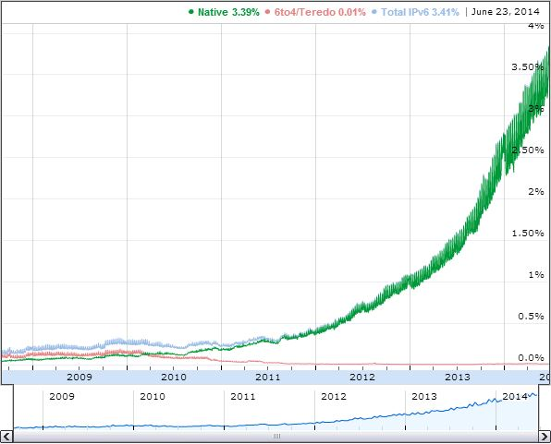

*Fig 5: IPv6 adoptation study on google’s official website.*

Yet the percentage is rapidly high but few countries in world are adoptoing IPv6 which is illustrated in Fig 6.

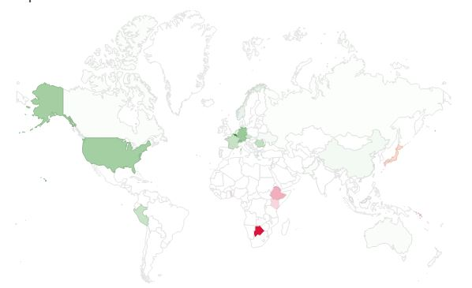

*Fig 6: Worldwide IPv6 adaptation*

In above map dark colored map represents use of IPv6.Only eleven countries has till now adapted IPv6 which is very slow and minimum in number.

# 6 CONCLUSIONS

Studying the fact about IPv6 specially its advantage over IPv4, readiness and adoptation I now have a clear vision that IPv6 will replace the IPv4 in coming few years. Studying for the term paper made a clear vision that IPv6 is a better alternative that IPv4 in many aspects.IPv6 is easy to configure and adaptable in almost all devices with latest technologies.

# BIBLIOGRAPHY

1. [RFC 760](http://tools.ietf.org/html/rfc760), DOD Standard Internet Protocol (January 1980)

<http://tools.ietf.org/html/rfc760>

2.[RFC 2460](http://tools.ietf.org/html/rfc2460), Internet Protocol, Version 6 (IPv6) Specification, S. Deering, R. Hinden, The Internet Society (December 1998)

<http://tools.ietf.org/html/rfc2460>

3.RFC791,Internet Protocol, DARPA INTERNET PROGRAM PROTOCOL SPECIFICATION(September 1981)

<http://tools.ietf.org/html/rfc791>

4. Internet Assigned Numbers Authority, (since 1988)

<https://www.iana.org>

5.Internet Protocol, Version 6 (IPv6) Specification, (December 1998),OFFICIAL INTERNET PROTOCOL STANDARDS

<http://www.rfc-editor.org/search/standards.php>

<http://tools.ietf.org/html/rfc2460#page-2>

6.SUSE LINUX – Administration Guide. Chapter 14. Linux in the Network / 14.2. IPv6 — The Next Generation Internet

<http://www.novell.com/documentation/suse91/suselinux-adminguide/html/ch14s02.html>

7. WIKIPEDIA : IPv6

<http://en.wikipedia.org/wiki/IPv6>

8.What if Internet ran our of room? <http://www.google.com/intl/en/ipv6/>

*9. IPv4 addresses allocation*

[*http://www.google.com/intl/en/ipv6/*](http://www.google.com/intl/en/ipv6/)

*10. IPv6 Readiness, Network world , (21 January 2010)*

[*http://www.networkworld.com/article/2242635/lan-wan/web-sites-must-support-ipv6-by-2012--expert-warns.html*](http://www.networkworld.com/article/2242635/lan-wan/web-sites-must-support-ipv6-by-2012--expert-warns.html)

*11. IPv6 adoptation study on google’s official website.*

[*http://www.google.com/intl/en/ipv6/statistics.html#tab=ipv6-adoption*](http://www.google.com/intl/en/ipv6/statistics.html#tab=ipv6-adoption)